C Programming Basics for Security
Objective
Understand C operators, file handling, and control structures with a cybersecurity lens.

File Handling with fopen
- "r" read (file must exist)
- "w" write (create new or truncate existing)
- "a" append (write at the end, keep existing contents)
- "r+" read & write (file must exist)
- "w+" read & write (truncate if exists)
- "a+" read & append

Safe Input with fgets
Important: fopen sets how the file is accessed, while fgets just reads lines from it. So, do not confuse fopen modes ("r", "w", "a") with fgets.
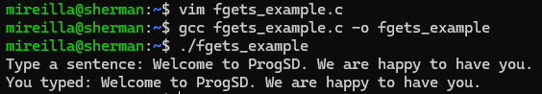

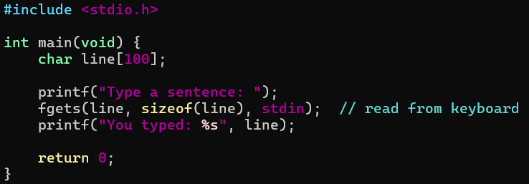
fgets means file get string. It reads a line of text (up to n-1 characters) into a buffer and automatically adds the null terminator \0.
Arguments:
line: buffer (char array) where the string will be stored.
sizeof(line): maximum number of characters to read (prevents overflow).
stdin: the input stream (keyboard by default).

Pointer & Address Operators
* (dereference) and & (address-of). Why is it important?
Many classic vulnerabilities come from pointer misuse. So, understanding * (dereference) and & (address-of) helps students see how attackers can control program memory.

Struct Access
Struct Access (. and ->). Why are they important?
They help understand memory access, which is fundamental for buffer overflows, pointer manipulation, and memory corruption exploits. In forensics, for example, analysts need to interpret memory dumps that often map directly onto struct layouts. So they use it to interpret binary data structures (e.g. packets, processes).
& Get the address of something (address-of operator). It should return the memory address of a variable. It is often used when assigning a pointer or passing a variable by reference to a function
* Go to the address and get the value. If p is a pointer to an int, then *p gives you the int stored at that address.
. Access struct member directly.
-> Access struct member through a pointer.

Operators & Loops
Unary Increment/Decrement (++, --)
Commonly used in loops, these operators are also relevant because off-by-one errors in them often lead to vulnerabilities. Unary operators act on a single operand. For example, -x negates x, and ++x increments x by one.
int x = 5;
int y = -x; // unary minus → makes x negative
In this example, the operator - is unary because it is applied to one variable (x).

Common binary operators:
- Arithmetic: + - * / %
- Relational: < > <= >= == !=
- Logical: && ||
- Bitwise: & | ^ << >>
- Assignment: =

Relational & Logical Operators
<, >, <=, >=, ==, !=, &&, ||, !
Why are they important?
Critical for input validation and conditional checks. Logic errors in conditions (e.g., == vs =) can introduce authentication bypasses.

Assignment & Shorthand Assignment
=, +=, -=, etc
Why is it important?
Mistakes like using = instead of == in conditionals are a classic security bug.

Bitwise Operators
&, |, ^, ~, <<, >>
Why is this important?
They are used heavily in cryptography, network packet manipulation, and access control flags (permissions, masks, etc.).
Example: chmod in Linux uses bitwise permission masks.

Sizeof Operator
sizeof()
Why is it important?
It is critical for safe memory allocation. So, misusing it can lead to memory corruption vulnerabilities.

Ternary Operator
Ternary operator works on three operands. There is only one ternary operator in C:
?:
In this code example:
If condition (age >= 18) is true → "Adult”
Else → "Minor"
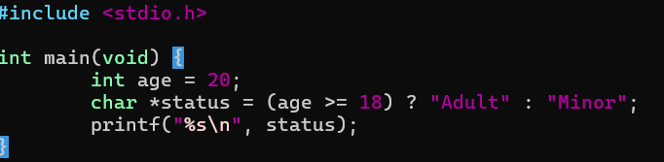
Output
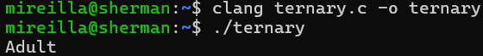
Useful shorthand in secure coding for validations and sanitization.
Example: int access = (user_is_admin ? 1 : 0);

Conditional Concepts in C Relevant to Cybersecurity
if / else statements are fundamental for access control, authentication, and input validation. For example, bugs like using = instead of == in conditionals can lead to authentication bypass vulnerabilities.
A for loop is a more efficient loop structure in 'C' programming
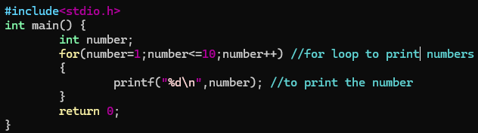

The initial value of the for loop is performed only once.
The condition is a Boolean expression that tests and compares the counter to a fixed value after each iteration, stopping the for loop when false is returned.
The incrementation/decrementation increases (or decreases) the counter by a set value.

In C, the for loop can have multiple expressions separated by commas in each part.
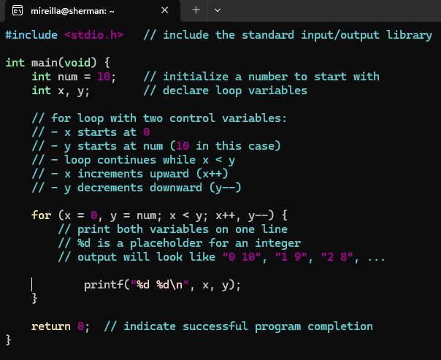
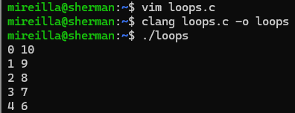

While loop and operator
Task: Read about the while loop and find out why this might be important in cybersecurity.

